Annette Bazan
Ali Zaidi
Ethan Phan
Rayyaan Haamid

January 21, 2026
ITAI 3377
A01 Understanding Development Environments and Tools for Edge AI and IoT
Edge AI and Internet of Things (IoT) systems rely on diverse ecosystems of development tools that support coding, machine learning model creation, deployment, and collaboration. My report will examine six widely used tools and platforms-Visual Studio Code, Node.js, Edge Impulse CLI, TensorFlow and TensorFlow Lite, Google Colab and Generative AI Coding Tools and explain their descriptions, purposes, and typical use cases in Edge AI and IoT development.
- Visual Studio Code (VS Code)
Description:
Visual Studio Code (VS Code) is a lightweight, open-source code editor developed by Microsoft. It supports multiple programming languages and platforms and is highly extensible through plugins and extensions.
Key features include:
- Built-in Git and GitHub integration
- IntelliSense for smart code completion
- Debugging tools for multiple languages
- Integrated terminal
- Large extension marketplace (Python, C/C++, Node.js, IoT, and AI tools)
Purpose:
VS Code is popular because it combines the simplicity of a text editor with the power of an Integrated Development Environment (IDE). Developers can customize it for different workflows, making it suitable for beginners and professionals alike.
Typical Use Cases in Edge AI and IoT:
- Writing and debugging Python Code for sensor data preprocessing on edge devices
- Developing firmware in C/C ++ for microcontrollers (examples: Arduino, ESP32)
- Managing Edge AI projects that integrate TensorFlow Lite models
- Using extensions for Docker, SSH and remote device management
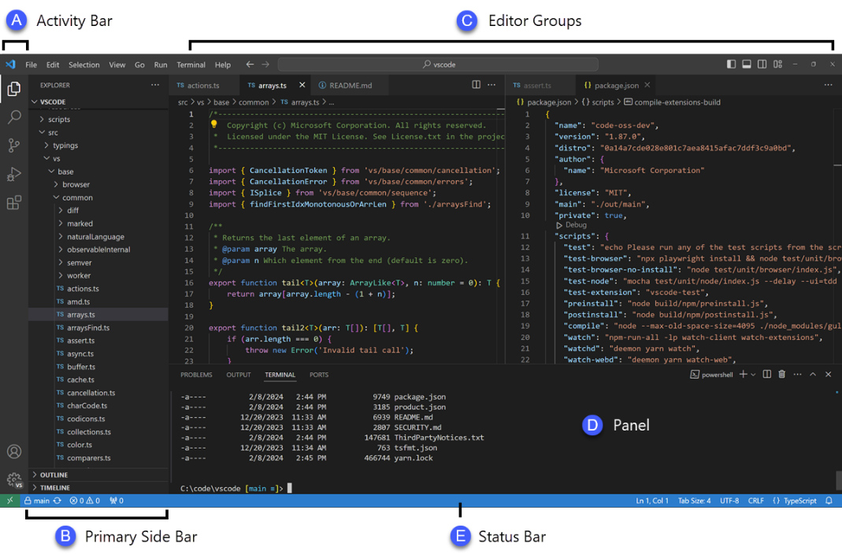
- Node.js
Description:
Node.js is an open-source, cross-platform JavaScript runtime environment built on Google Chrome’s V8 JavaScript engine. Unlike traditional JavaScript usage, which is limited to web browsers, Node.js allows developers to run JavaScript code directly on servers and edge devices. It is designed to build scalable and efficient network applications. A defining characteristic of Node.js is its event-driven, non-blocking I/O model, which allows it to handle multiple operations concurrently without waiting for tasks such as file access or network requests to complete. This makes Node.js suitable for applications that must process large volumes of data or maintain many simultaneous connections. Because Node.js uses JavaScript it enables developers to use the same language across the full stack. From edge devices and servers to web dashboards it reduces development complexity and improves maintainability.
Key features include:
- Single-threaded event loop optimized for asynchronous operations
- The Node Package Manager (npm) which provides access to hundreds of thousands of reusable libraries and frameworks
- Native support for RESTful APIs, JSON handling, and real-time communication
- Compatibility with multiple operating systems, including Windows, macOS, Linus, and embedded Linux environments
Purpose:
Node.js is widely used for server-side scripting and real-time applications because it can handle many concurrent connections efficiently. This makes it ideal for applications that require fast data exchange between servers and devices.
Typical Use Cases in Edge AI and IoT:
- Building lightweight backend servers to collect data from IoT sensors
- Creating REST APIs for Edge AI systems
- Managing real-time data streams using WebSockets or MQTT brokers
- Acting as a gateway between edge devices and cloud services
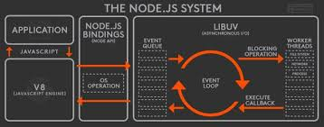
- Edge Impulse CLI
Description:
The Edge Impulse Command Line Interface (CLI) is a development tool provided by Edge Impulse to support building, training, and deploying machine learning models for edge devices. It enables developers to interact with Edge Impulse projects directly from their local development environment rather than relying solely on a web-based interface. The CLI is typically installed using Node.js and npm and provides direct access to Edge Impulse services such as data ingestion, model training, testing, and deployment. It supports a wide range of edge hardware platforms, including microcontrollers, single-board computers (e.g., Raspberry Pi), and embedded Linux systems. By being able to seamlessly integrate with local development tools like VS Code, the Edge Impulse CLI allows developers to automate workflows and iterate quickly during Edge AI development.
Key features include:
- Secure authentication and project management from the command line
- Real-time data collection from sensors such as accelerometers, microphones, cameras, and environmental sensors.
- Data labeling and synchronization with Edge Impulse cloud platform
- Launching training jobs and evaluating model performance
- Exporting optimized machine learning models for specific hardware targets
Purpose:
The primary purpose of the Edge Impulse CLI is to simplify and accelerate the development of machine learning models for edge devices. It provides a streamlined workflow that connects raw sensor data to deployable, optimized models while abstracting much of the underlying complexity. The CLI enables developers to rapidly prototype Edge AI solutions. Ensure models are optimized for memory, power, and performance constraints. Maintains reproducible workflows suitable for both academic and production environments. This makes Edge Impulse CLI especially valuable for Edge AI applications where resources are limited and efficiency is critical.
Typical Use Cases in Edge AI and IoT:
- Collecting motion, audio or image data directly from edge devices during field testing
- Training classification and anomaly detection models for predictive maintenance or activity recognition
- Validating model accuracy and performance before deployment
- Exporting models compatible with TensorFlow Lite, Arduino libraries, or custom C/C++ firmware
- Integrating trained models into embedded systems for real-time, on-devices inference
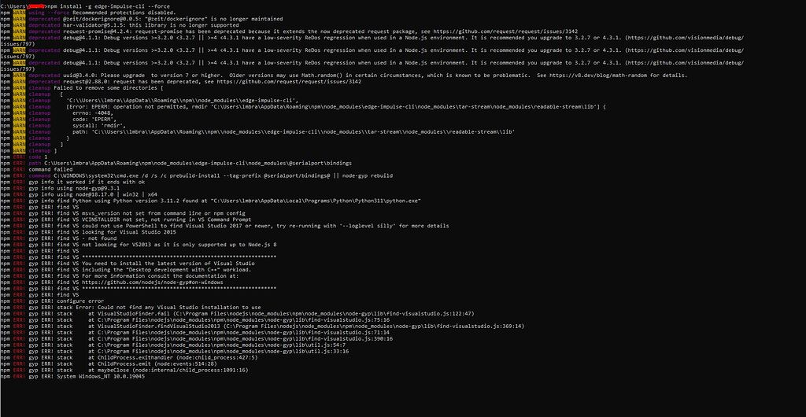
- TensorFlow and TensorFlow Lite
Description:
TensorFlow is an open-source machine learning framework developed by Google for building and training deep learning models. TensorFlow supports a wide range of tasks that include image recognition, natural language processing, time-series analysis and reinforcement learning. TensorFlow Lite is a lightweight version designed specifically for deployment on edge and mobile devices. It focuses on reduced model size, lower latency and efficient inference on hardware with limited computational power, memory, and energy availability.

Key Features include:
- TensorFlow: Full-featured framework for training and experimentation
- Supports CPUs, GPUs, and TPUs for accelerated training
- High-level APIs such as Keras for rapid model development
- Extensive model optimization and evaluation tools
- Strong ecosystems with TensorFlow Hub, TensorBoard and TensorFlow Extended (TFX)
- TensorFlow Lite: Optimized for low power, low memory and faster inference
- Smaller binary size suitable for embedded systems
- Supports model quantization to reduce memory usage (int8, float16)
- Hardware acceleration support (e.g Edge TPU, GPU, NNAPI)
- Designed for on-device inference rather than training
Purpose:
TensorFlow is primarily used during model development and training while TensorFlow Lite enables efficient deployment of trained models on resource constrained devices. The purpose of TensorFlow is to provide a powerful and flexible platform for designing, training, and validating machine learning models. It is widely used in research, education, and production environments to develop sophisticated AI solutions. TensorFlow Lite’s purpose is to bridge the gap between machine learning and research and real-world deployment by enabling efficient execution of models on resource-constrained devices. It ensures that AI models can run locally on edge devices, reducing dependence on cloud connectivity. Together they support the complete machine learning lifecycle from model conception and training to deployment and inference at the edge.
Typical Use Cases in Edge AI and IoT:
- Training computer vision or sensor-based models using TensorFlow on cloud or local machines
- Converting trained models to TensorFlow Lite format for deployment
- Running real-time inference on edge devices such as Raspberry Pi, ESP32, or mobile phones
- Enabling offline decision-making in IoT systems where low latency and privacy are critical
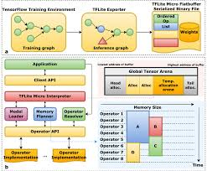
- Google Colab
Description:
Google Colab is a cloud-based development environment that allows users to write and execute Python code in a web browser. It is based on Jupyter notebooks and provides access to free or paid GPU and TPU resources.
Key features include:
- No local installation required
- Free access to GPUs and TPUs
- Easy sharing and collaboration
- Integration with Google Drive
Purpose:
Google Colab facilitates cloud-based development by providing a ready-to-use environment for data analysis, machine learning, and experimentation. It is especially useful for education, prototyping and collaboration.
Typical Use Cases in AI and IoT Development:
- Training and testing machine learning models
- Data preprocessing and visualization for IoT datasets
- Experimenting with TensorFlow and TensorFlow Lite conversions
- Sharing notebooks with team members or instructors
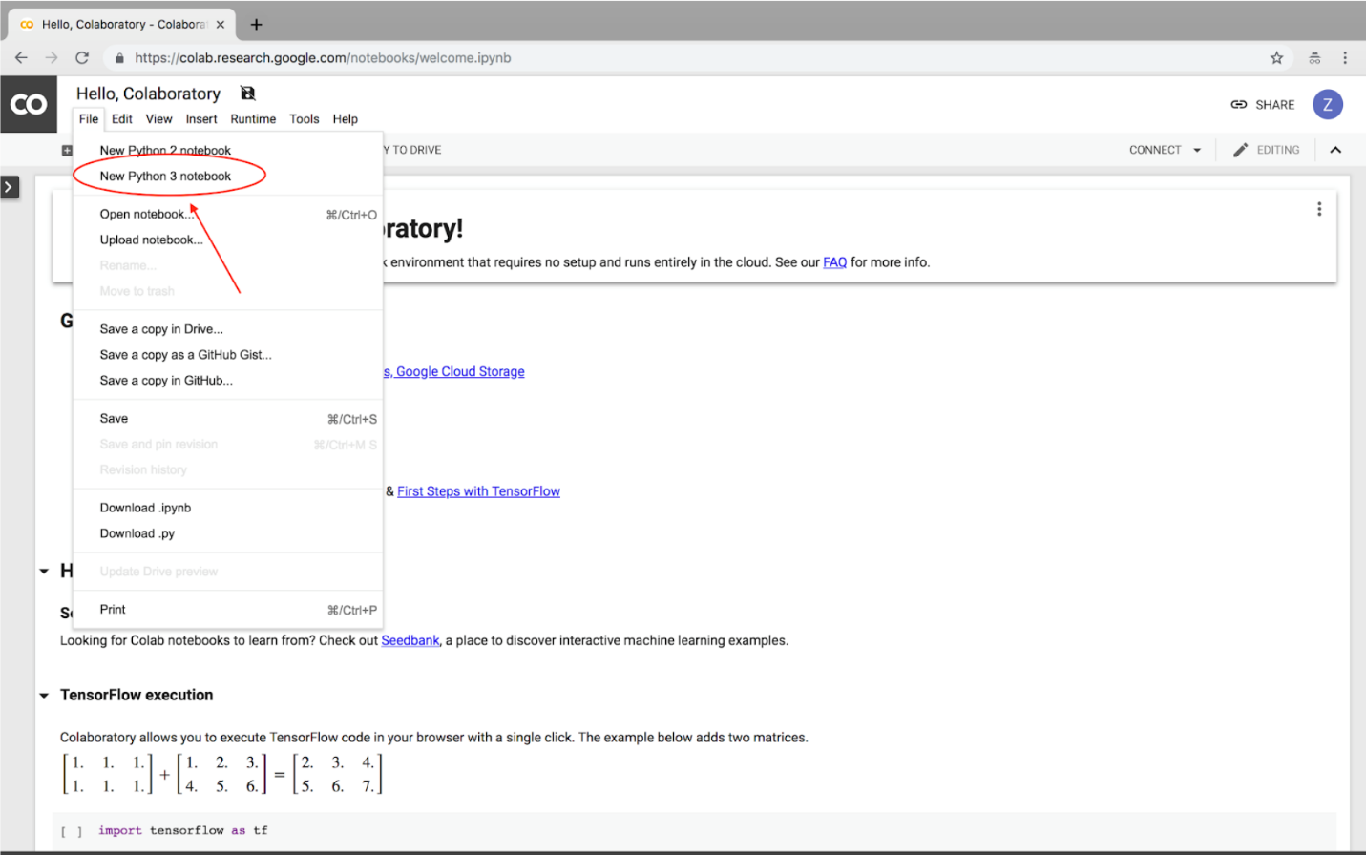
- Generative AI Coding Tools (e.g., GitHub Copilot, OpenAI Codex)
Description:
Generative AI coding tools are software development assistants powered by LLMs that can understand natural language prompts and existing code context to generate, complete, explain and refactor source code. These tools are commonly integrated directly into development environments such as Visual Studio Code, enabling real-time assistance while coding. They are trained on large datasets consisting of publicly available code, programming documentation, and common software patterns. Because of this training, generative AI tools can recognize syntax, APIs and best practices across many programming languages and development frameworks.
Key features include:
- Context-aware code auto-completion and generation
- Natural language-to-code translation
- Support Multiple programming languages (Python, JavaScript, C/C ++, Java, etc.)
- Inline explanations and automatic code comments
- Assistance with debugging and error resolution
- Code refactoring and optimization suggestions
- Seamless integration with IDEs and version control systems
Purpose:
The primary purpose of generative AI coding tools is to improve developer productivity and reduce the time spent on repetitive or boilerplate coding tasks. By providing intelligent suggestions and automation these tools allow developers to focus on higher-level design, logic, and system architecture. In educational and professional environments generative AI coding tools also act as learning aids. They help developers understand unfamiliar libraries, frameworks, and syntax, making them especially useful for rapid development and skill building in emerging fields such as Edge AI and IoT.
Typical Use Cases in Edge AI and IoT Development:
- Generating boilerplate code for IoT device communication
- Assisting with sensor data collection and preprocessing logic
- Writing TensorFlow or TensorFlow Lite inference code
- Debugging data flow between edge devices, gateways, and cloud services
- Rapid prototyping of Edge AI applications and backend services
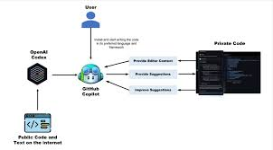
References
Edge Impulse. (n.d.). Edge Impulse documentation.
https://docs.edgeimpulse.com
Google. (n.d.). TensorFlow documentation.
https://www.tensorflow.org
Google. (n.d.). TensorFlow Lite documentation.
https://www.tensorflow.org/lite
Google. (n.d.). Google Colaboratory documentation.
https://colab.research.google.com
Microsoft. (n.d.). Visual Studio Code documentation.
https://code.visualstudio.com/docs
Node.js Foundation. (n.d.). Node.js documentation.
https://nodejs.org/en/docs
GitHub. (n.d.). GitHub Copilot documentation.
https://docs.github.com/en/copilot
OpenAI. (n.d.). OpenAI Codex overview.
https://platform.openai.com/docs

